Data Type:
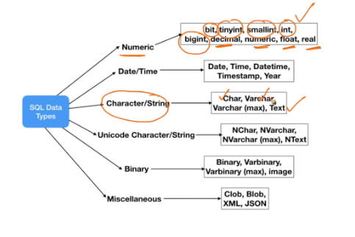
MySQL String Data Types
MySQL Numeric Data Types:
MySQL Date and Time Data Types:

